11.72: a) Take torques about the upper corner of the curb. The force 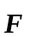acts at a perpendicular distance 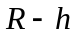 and the weight acts at a perpendicular distance 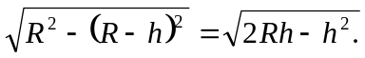Setting the torques equal for the minimum necessary force,
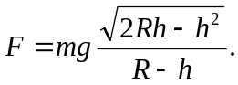
b) The torque due to gravity is the same, but the forceacts at a perpendicular distance 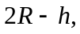so the minimum force is 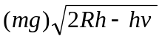/2R–h. c) Less force is required when the force is applied at the top of the wheel.

